2. Champagne Tower

Aim
To determine the amount of champagne present in a particular glass of a champagne tower after pouring a given quantity of champagne.

Algorithm
- Read the amount of champagne poured.
- Represent the champagne tower using rows of glasses.
- Pour the champagne into the top glass.
- If a glass contains more than 1 unit, the extra amount is divided equally between the two glasses below it.
- Repeat this process for all rows.
- Find the required glass using its row and position.
- The maximum amount in one glass is limited to 1 unit.
- Display the amount of champagne in the required glass.

Procedure
- Open Python IDLE, VS Code, or an online Python compiler.
- Enter the program given below.
- Run the program.
- Enter the amount of champagne poured.
- Enter the required row and glass position.
- The program calculates the champagne amount in that glass.
- Observe and record the output.
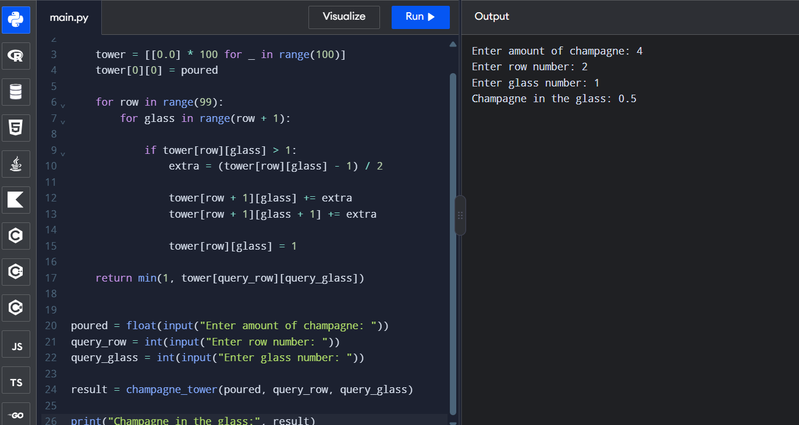

Result
Thus, the amount of champagne present in the specified glass of the champagne tower was successfully calculated using Python.

